**SELECT** * **FROM** SAPHANADB.z104329emp; 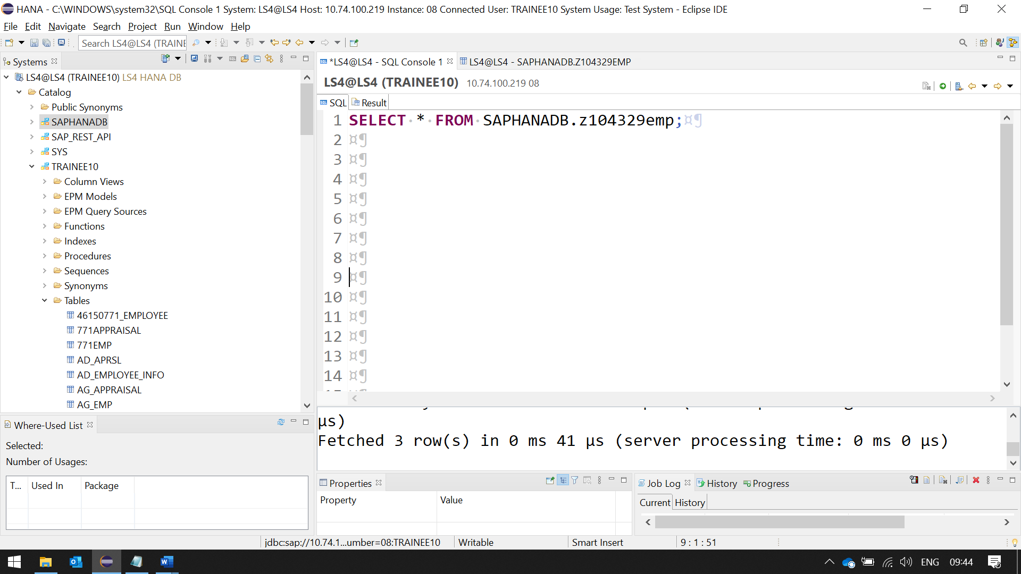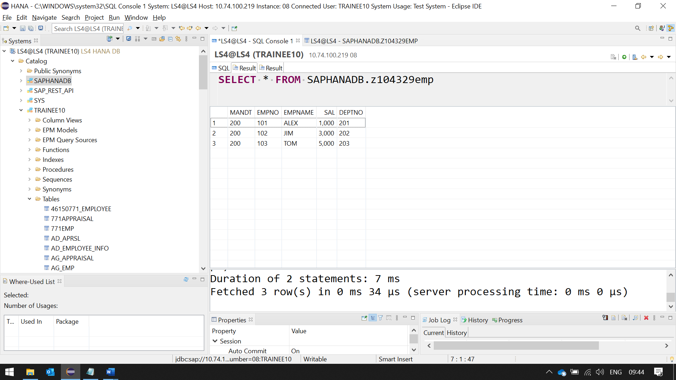 **SELECT** EMPNO ,EMPNAME, DEPTNO, 'SAL' **as** Emptype

**FROM** SAPHANADB.z104329emp;

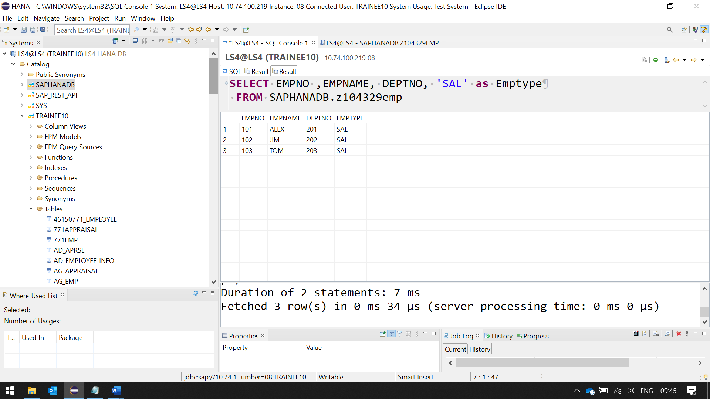

INNER JOIN

**select**

E.EMPNO,

E.EMPNAME,

E.SAL,

E.DEPTNO,

D.DNAME,

D.LOC

**from** SAPHANADB.Z104329EMP E

**inner** **join**

SAPHANADB.Z104329DEPT D

**on** E.DEPTNO = D.DEPTNO;

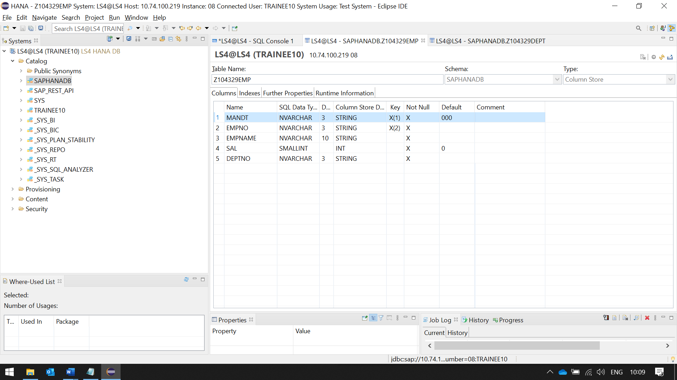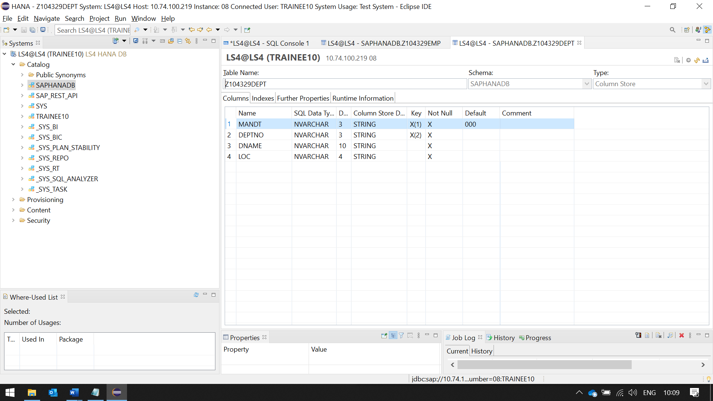 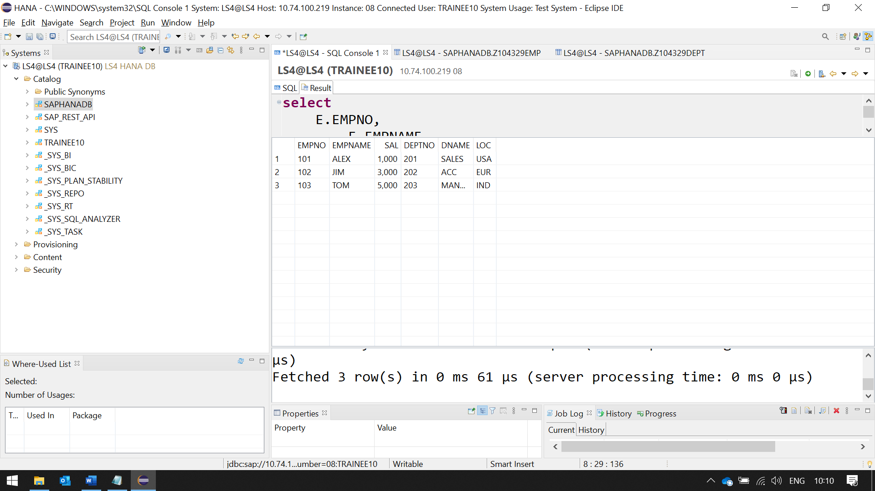

LEFT OUTER JOIN

**select**

E.EMPNO,

E.EMPNAME,

E.SAL,

E.DEPTNO,

D.DNAME,

D.LOC

**from** SAPHANADB.Z104329EMP E

**left** **outer** **join**

SAPHANADB.Z104329DEPT D

**on** E.DEPTNO = D.DEPTNO;

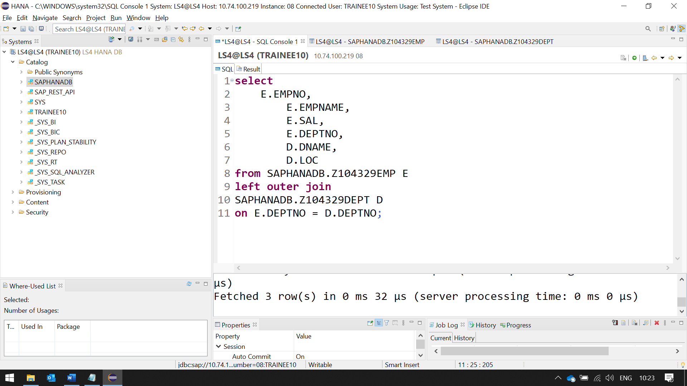

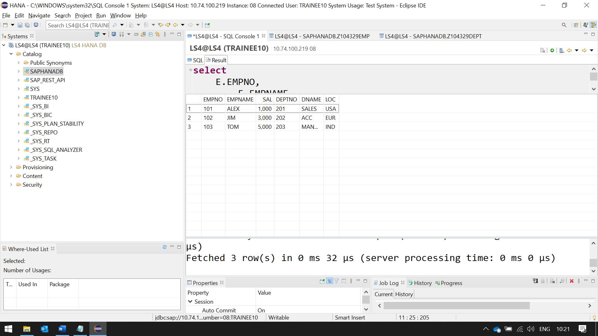

RIGHT OUTER JOIN

**select**

E.EMPNO,

E.EMPNAME,

E.SAL,

E.DEPTNO,

D.DNAME,

D.LOC

**from** SAPHANADB.Z104329EMP E

**right** **outer** **join**

SAPHANADB.Z104329DEPT D

**on** E.DEPTNO = D.DEPTNO;

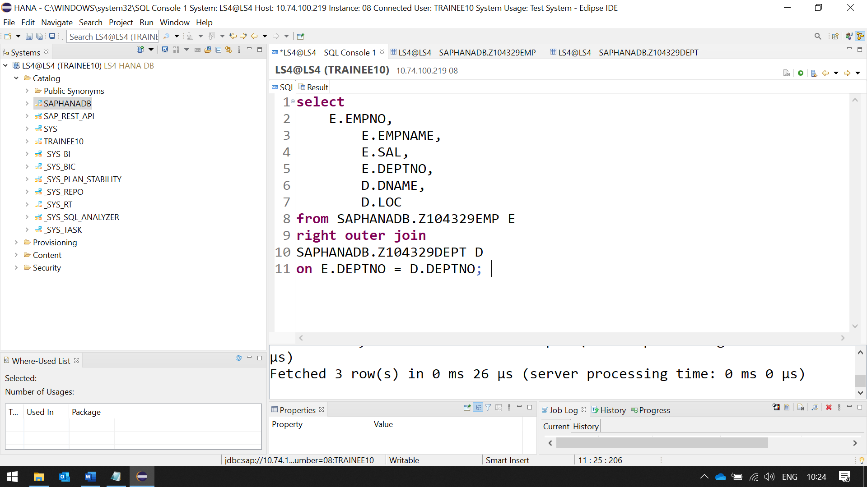 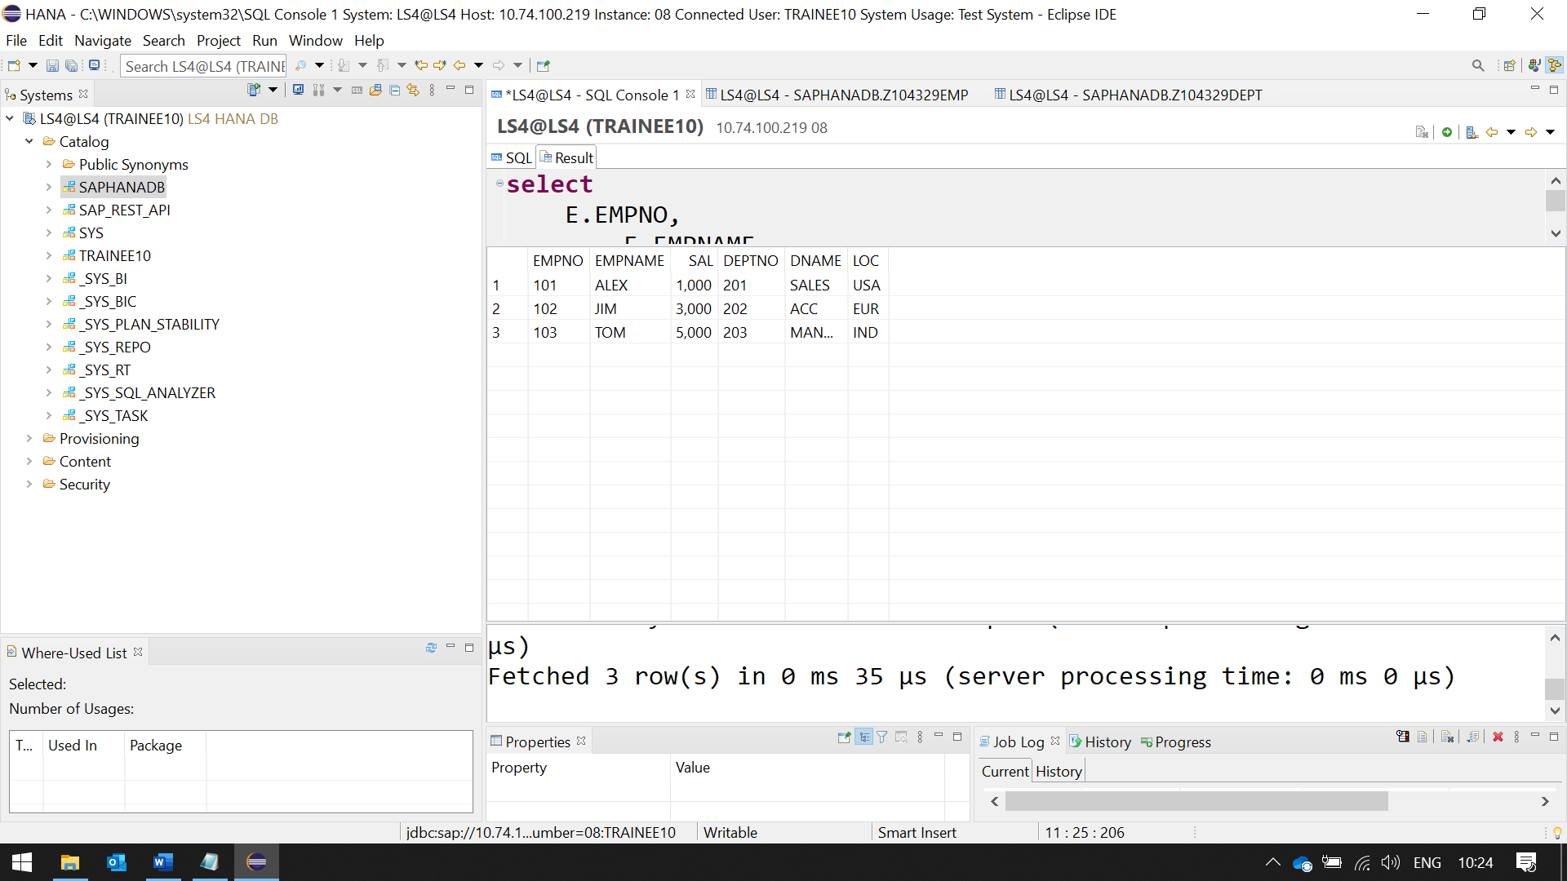

CASE AND END CASE

**select**

E.EMPNO,

E.EMPNAME,

E.SAL,

E.DEPTNO,

E.SAL,

D.DNAME,

D.LOC,

**case**

**when** E.SAL **between** 1 **and** 1500 **then** 'LOW'

**when** E.SAL **between** 1501 **and** 3000 **then** 'MEDIUM'

**when** E.SAL > 3000 **then** 'HIGH'

**else** 'NA'

**end** **as** grade

**from** SAPHANADB.Z104329EMP E

**inner** **join**

SAPHANADB.Z104329DEPT D

**on** E.DEPTNO = D.DEPTNO;

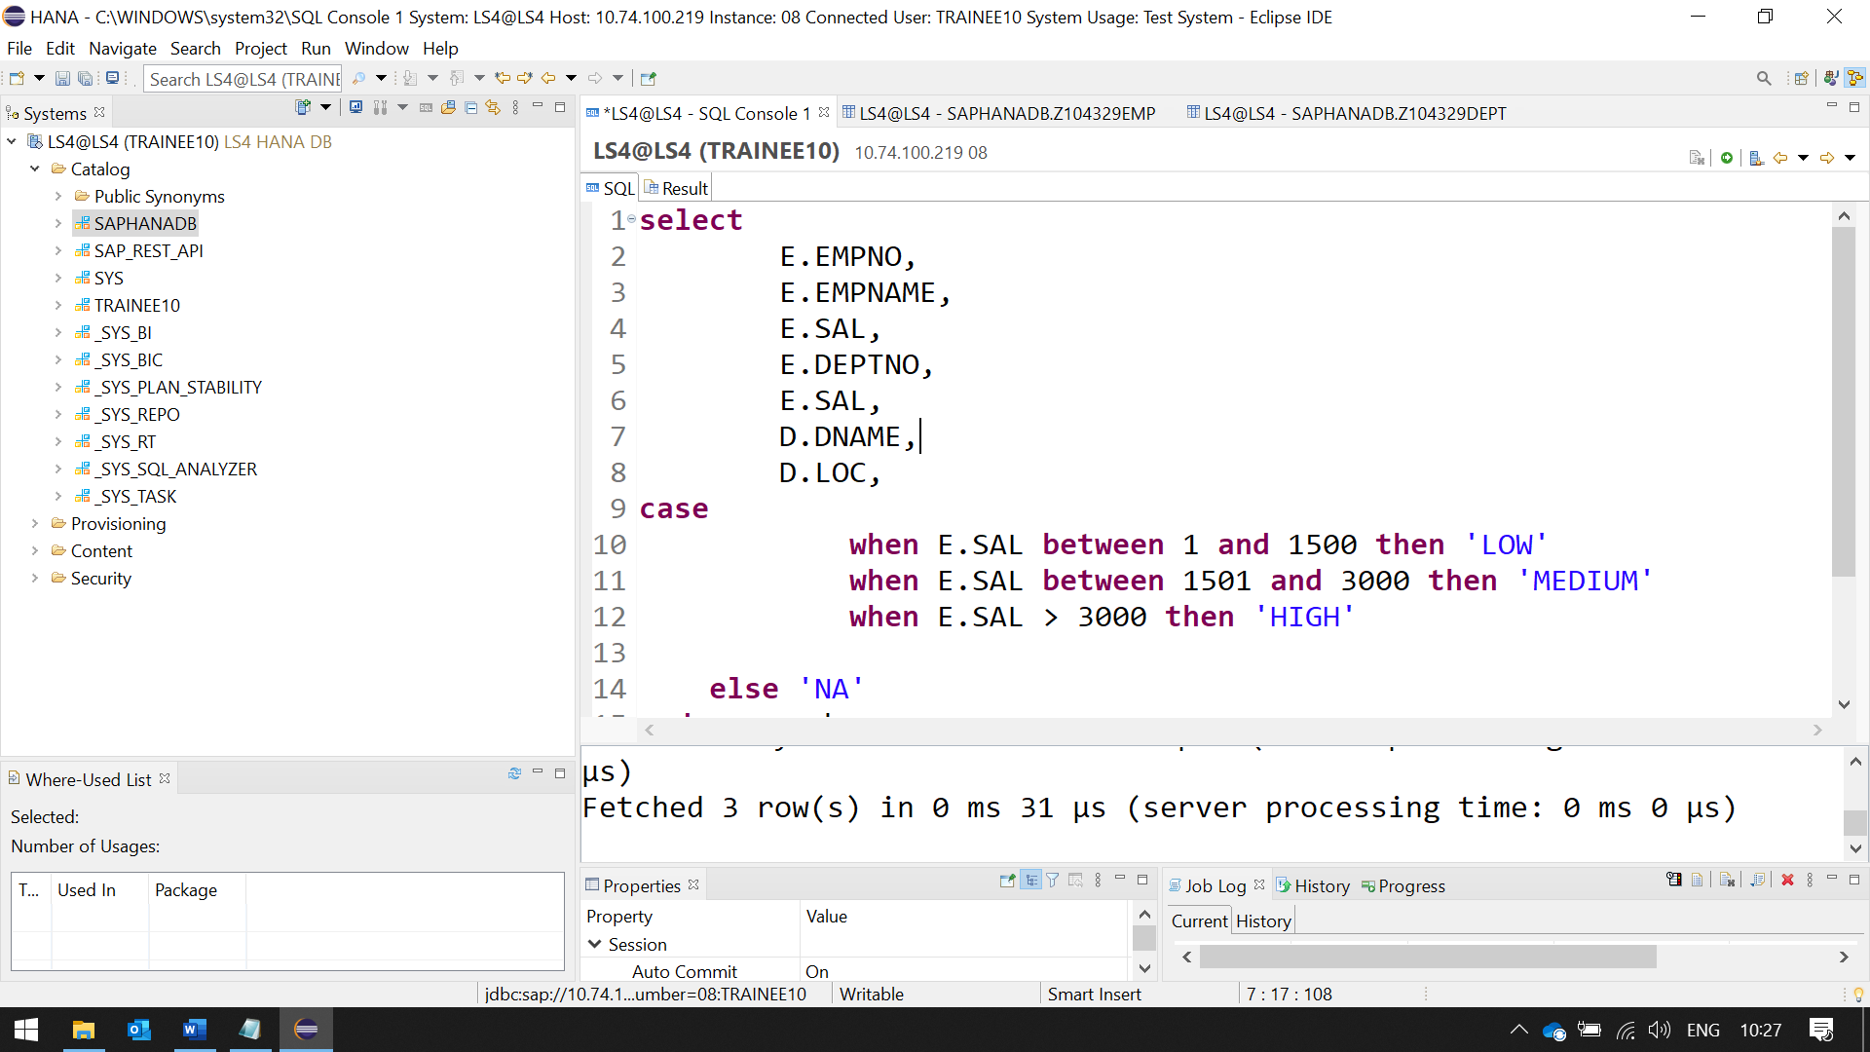

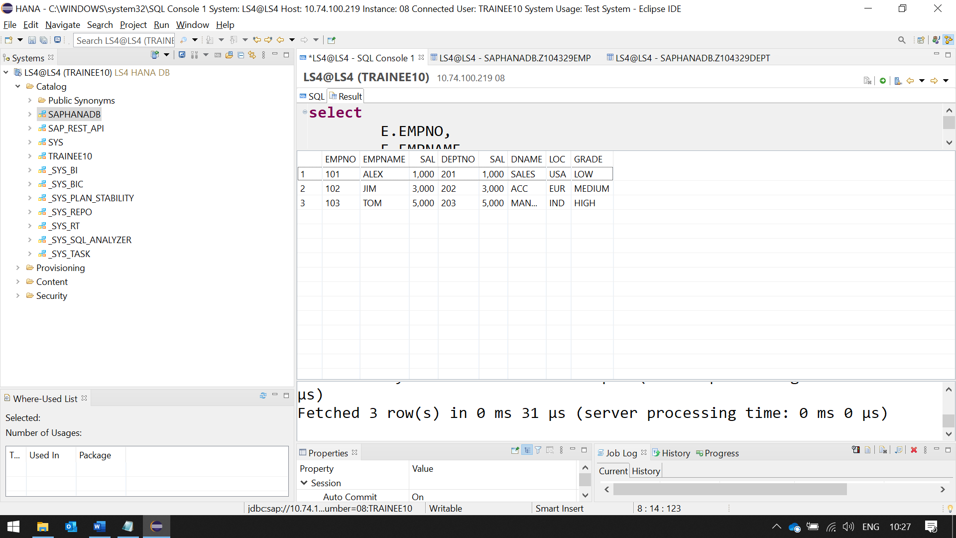

GROUP BY

**select**

**Sum**(Sal)

Deptno

**from** SAPHANADB.Z104329EMP

**group** **by** Deptno; 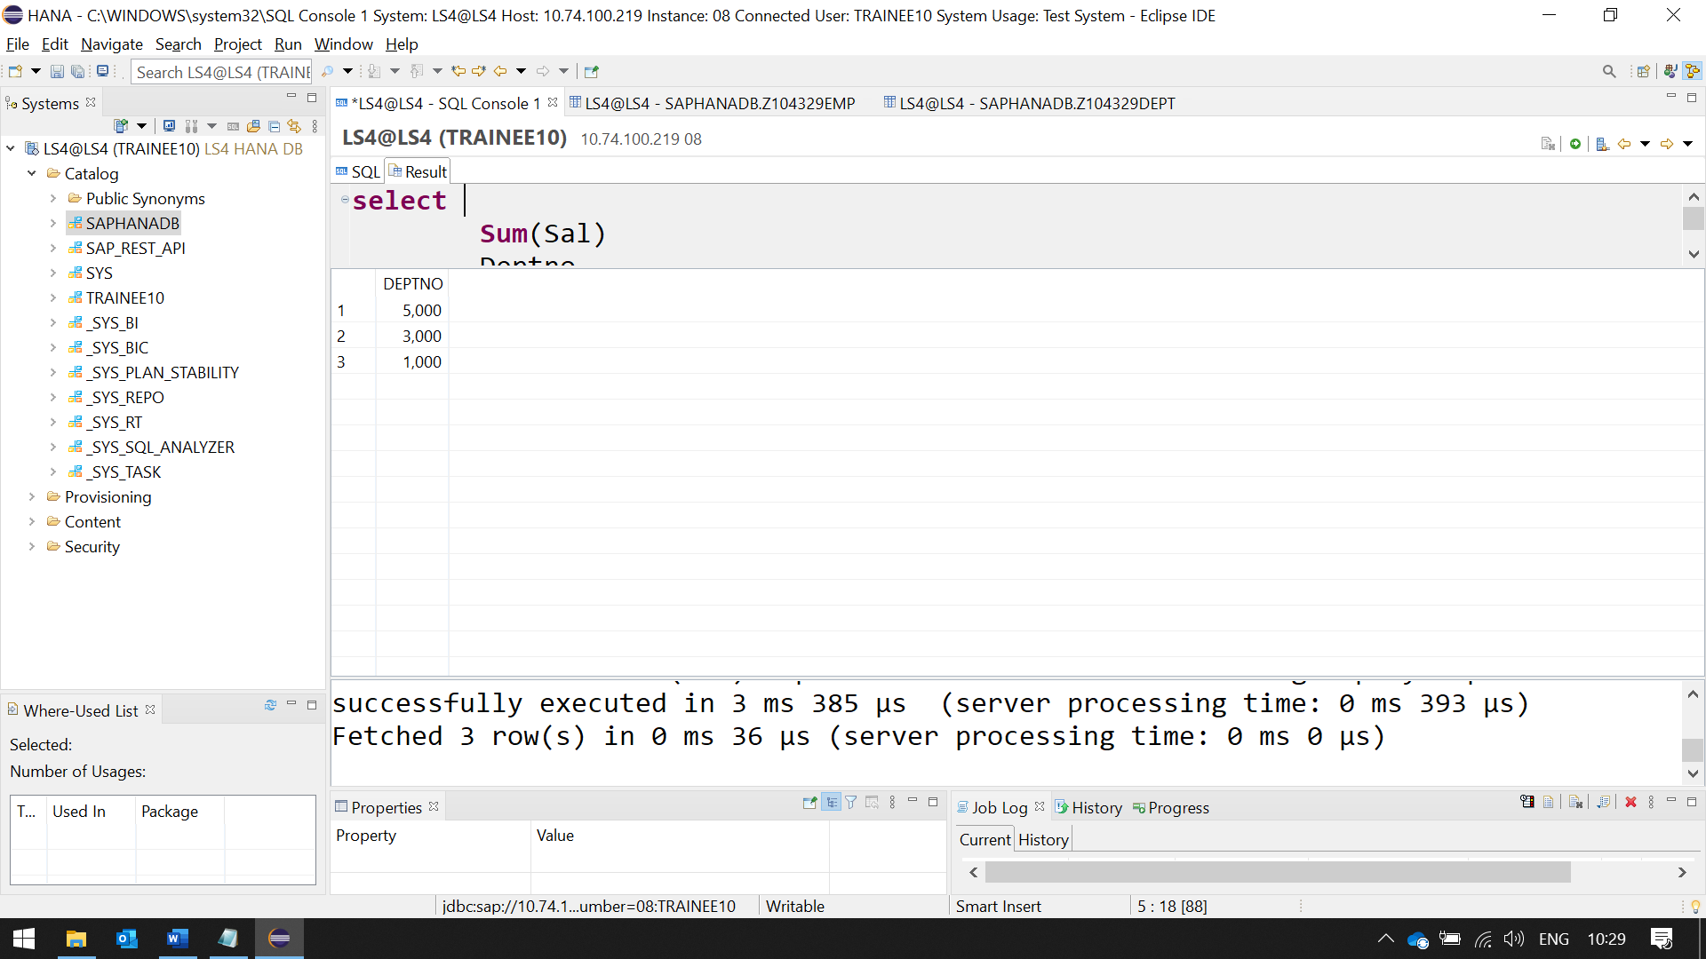

HAVING

**select**

**Sum** (Sal)

Deptno

**from** SAPHANADB.Z104329EMP

**group** **by** Deptno

**having** **sum**(Sal) > 10000; 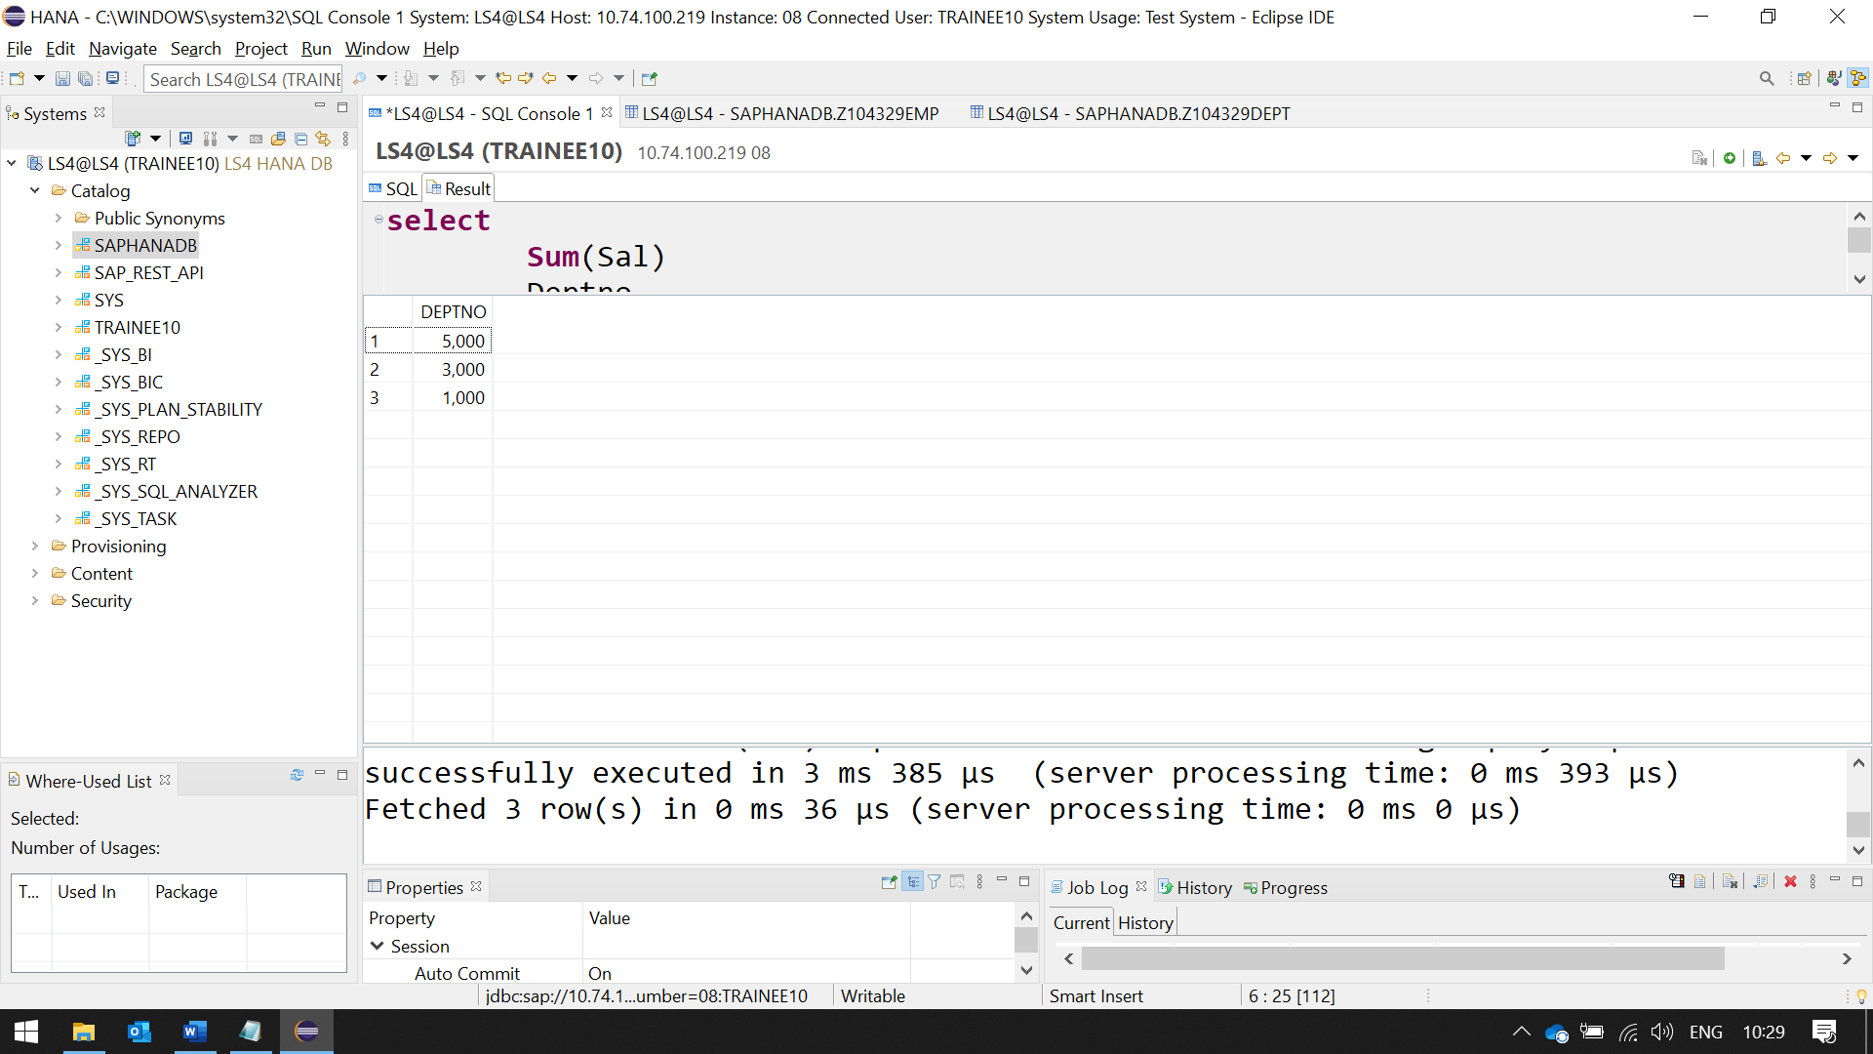

UNION THIS WILL MERGE THE OUTPUT DATA FROM QUERY

REPETITION WILL NOT BE PRINTED

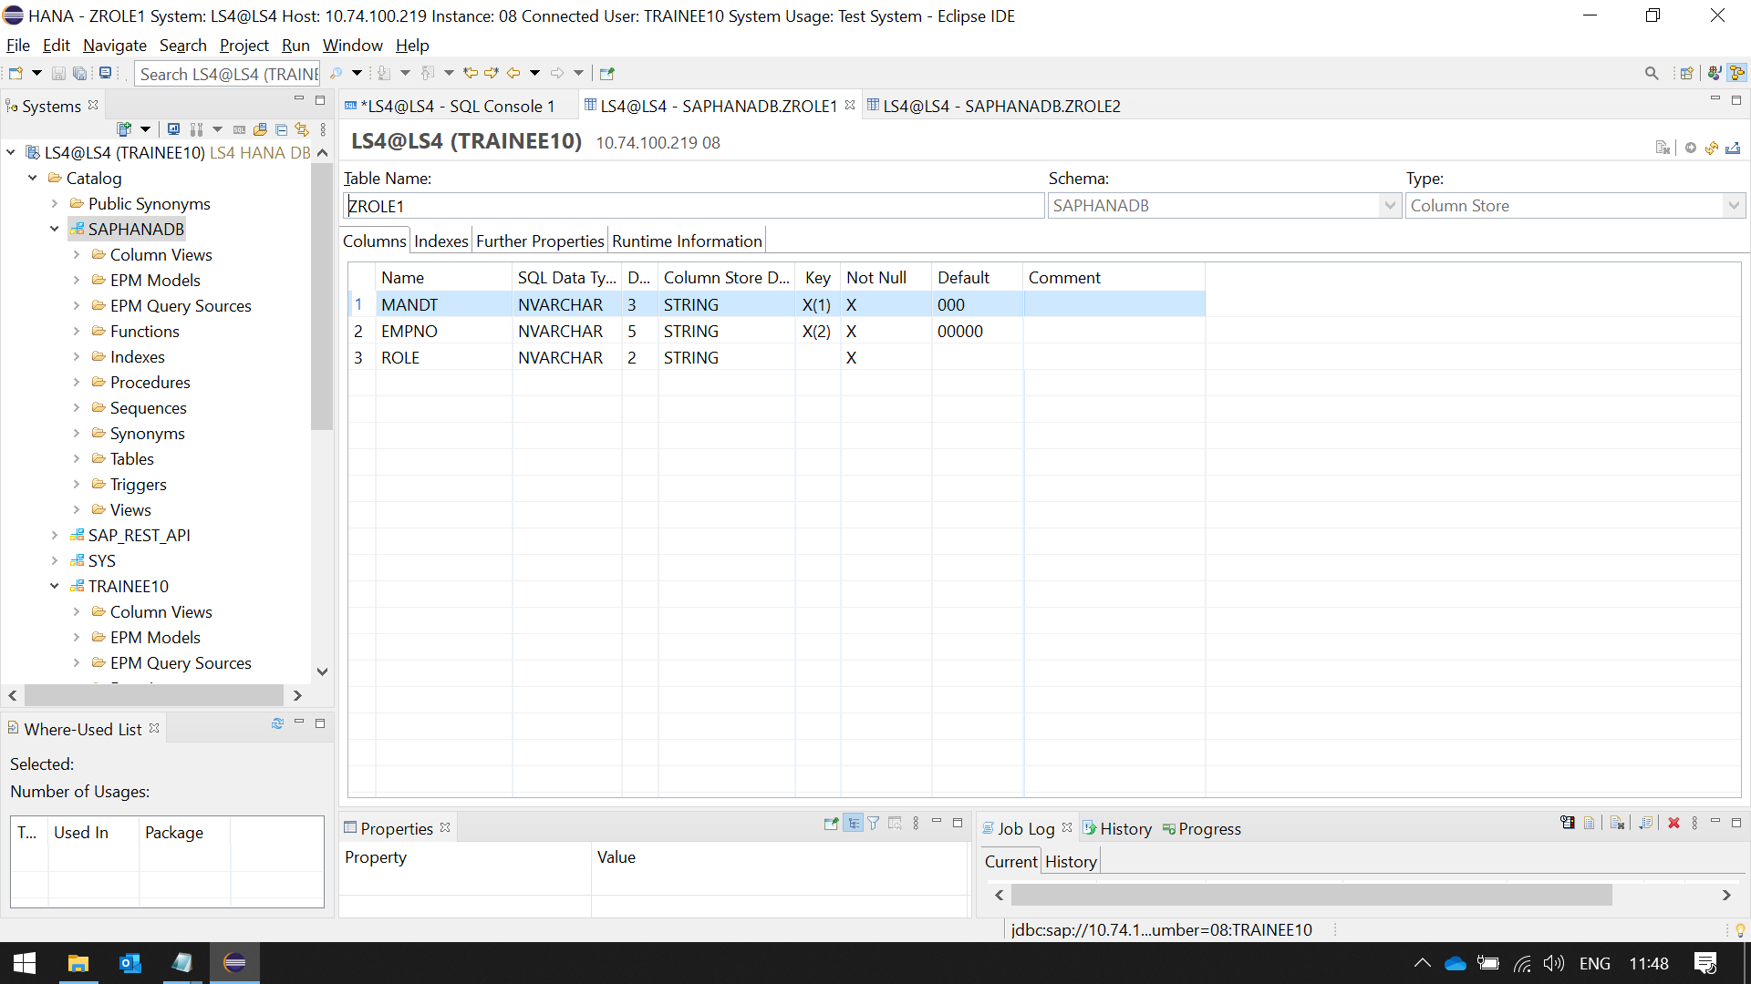

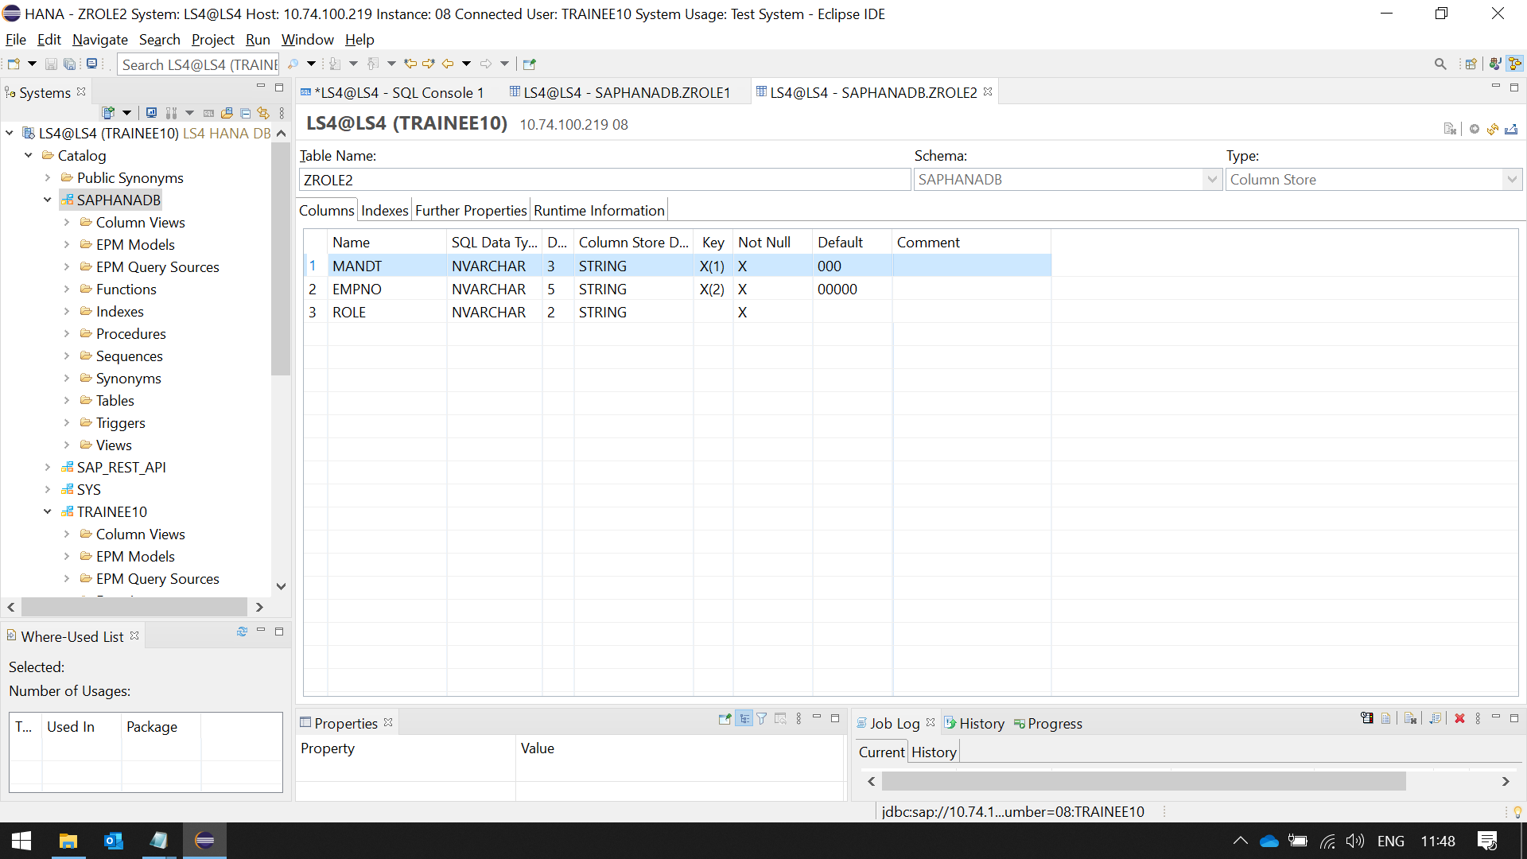 **select** * **from** SAPHANADB.zRole1

**union**

**select** * **from** SAPHANADB.zRole2

UNION ALL SAME AS UNION, BUT IT WILL ALLOW REPETITION

**select** * **from** SAPHANADB.zRole1

**union** **all**

**select** * **from** SAPHANADB.zRole2

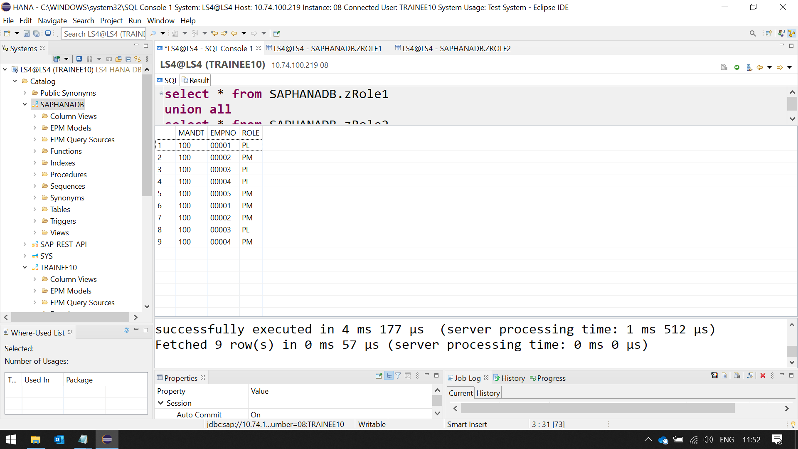

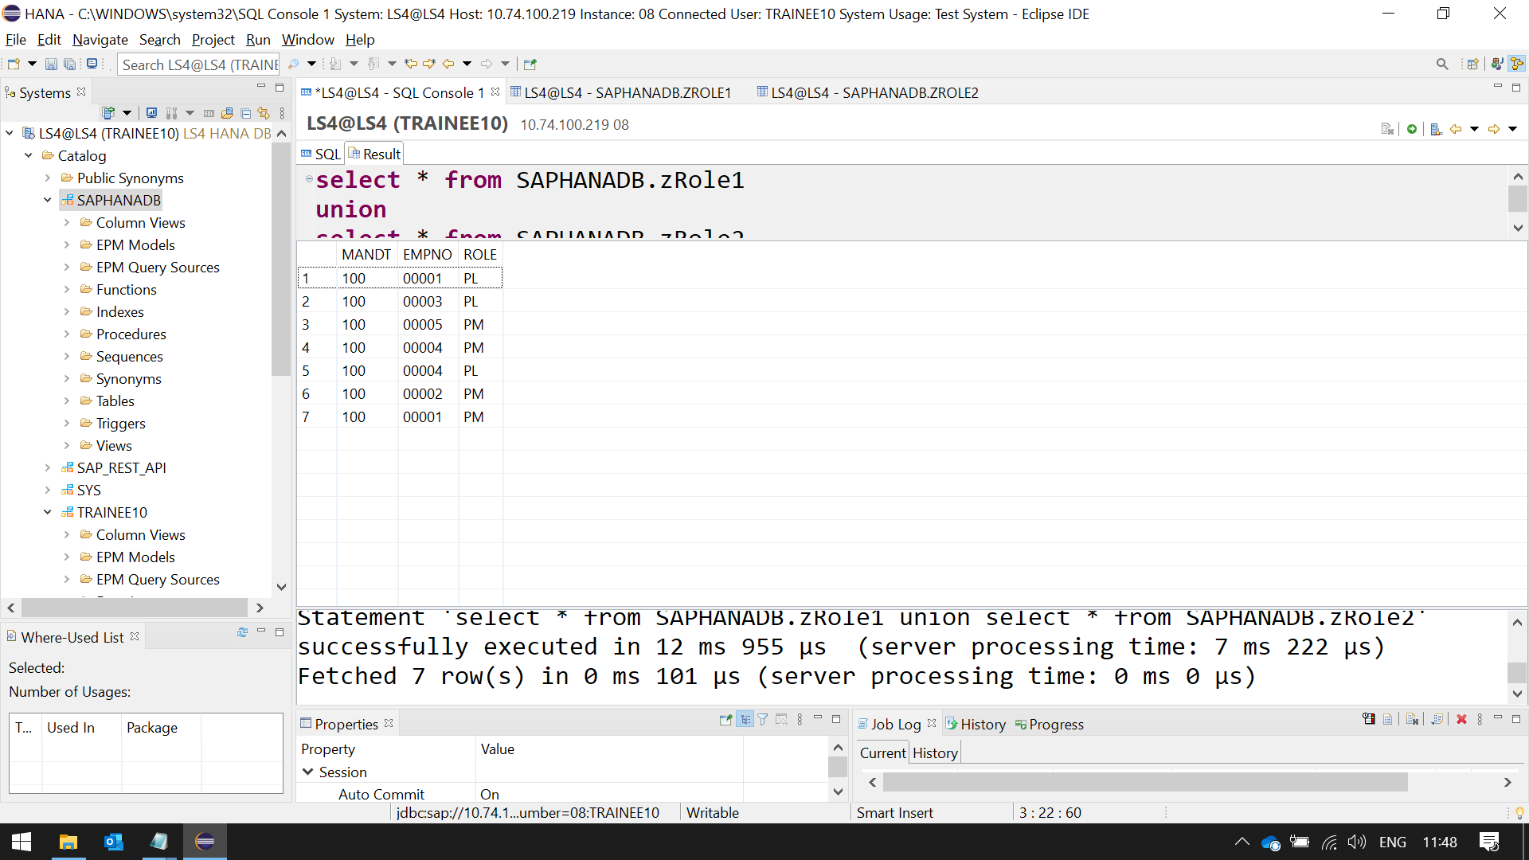

NESTED QUERY

**select** * **from** SAPHANADB.z104329emp

**where** sal > (**select** sal **from** SAPHANADB.z104329emp **where** EMPNAME = 'SMITH')

VIEW

**create** **view** zvkview **as**

**select**

E.EMPNO,

E.EMPNAME,

E.SAL,

E.DEPTNO,

D.DNAME,

D.LOC,

**case**

**when** E.SAL **between** 1 **and** 1500 **then** 'LOW'

**when** E.SAL **between** 1501 **and** 3000 **then** 'MEDIUM'

**when** E.SAL > 3000 **then** 'HIGH'

**else** 'NA'

**end** **as** grade

**from** SAPHANADB.Z104329EMP E

**inner** **join**

SAPHANADB.Z104329DEPT D

**on** E.DEPTNO = D.DEPTNO;

**select** * **from** zvkview;

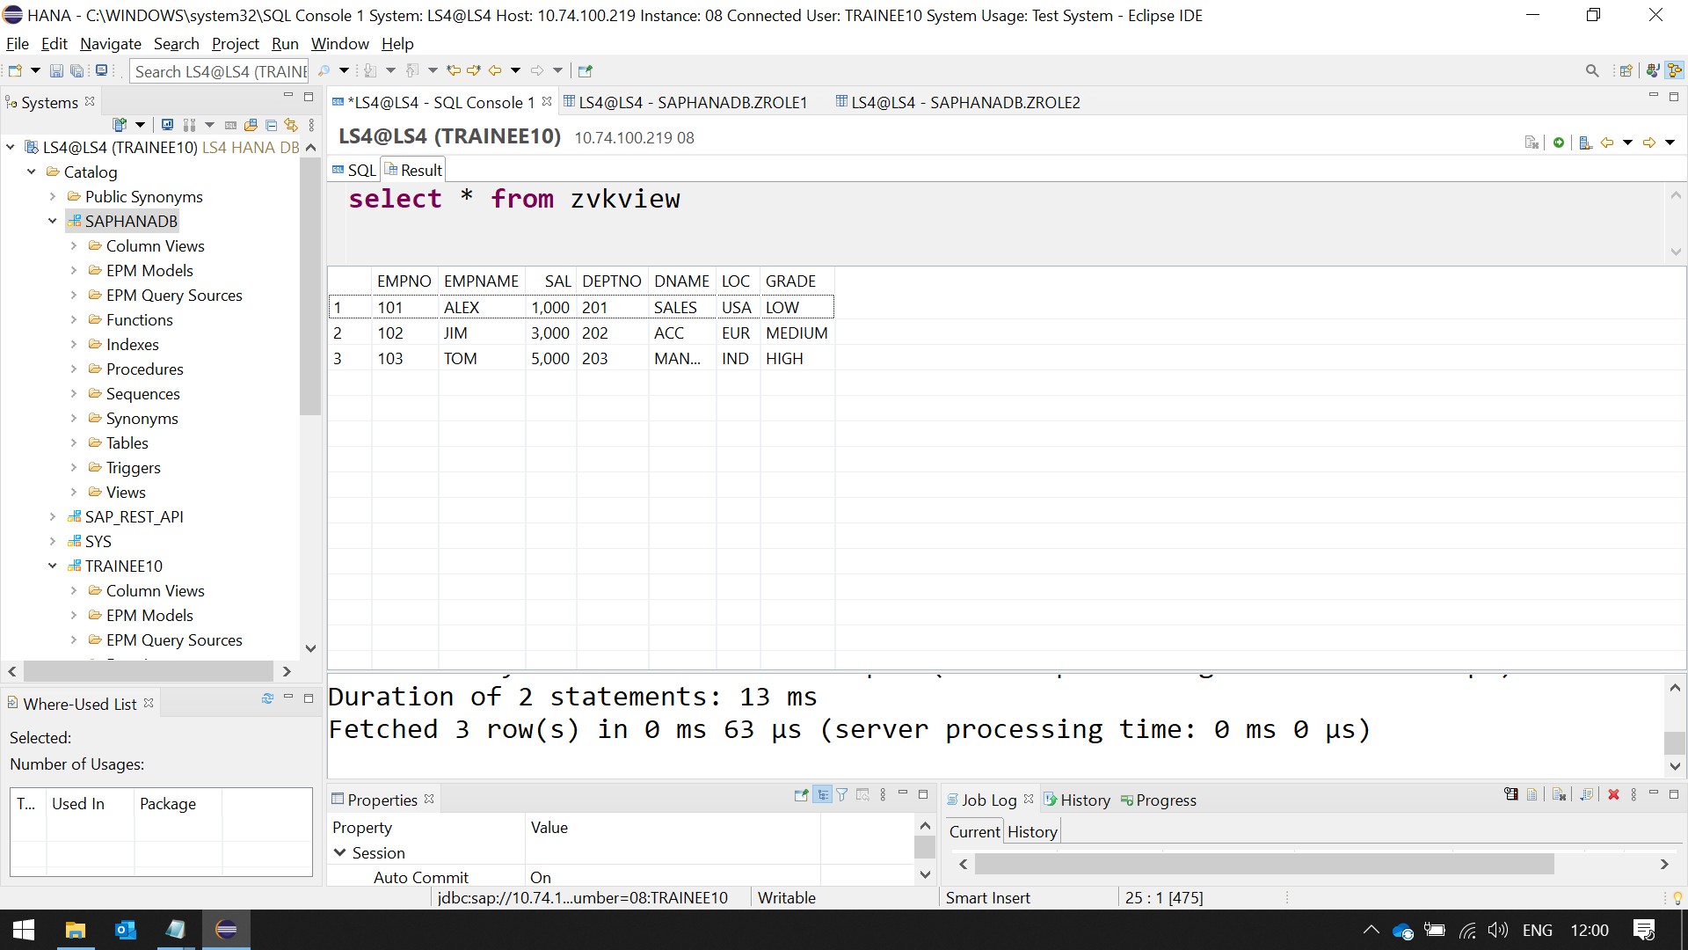

CREATING COLUMN TABLE

**Create** **column** **Table** MT_18 (

KUNNR **VARCHAR**(10) **primary** **key**,

FNAME **VARCHAR**(25),

LNAME **VARCHAR**(25),

EMAIL **VARCHAR**(25),

FAX **VARCHAR**(10),

AEDAT **DATE**,

ACTIVE **varchar**(1)

);

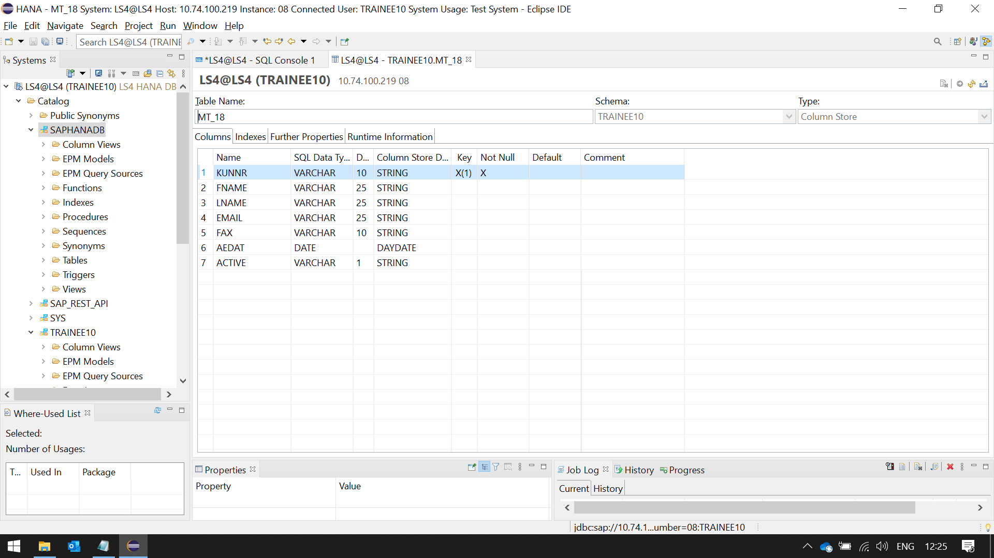

**insert** **into** TRAINEE10.MT_18 **values**('1001','SAP1000','PVTLTD','SAP1000@GMAIL.COM','02-3344556','2018/01/08','X');

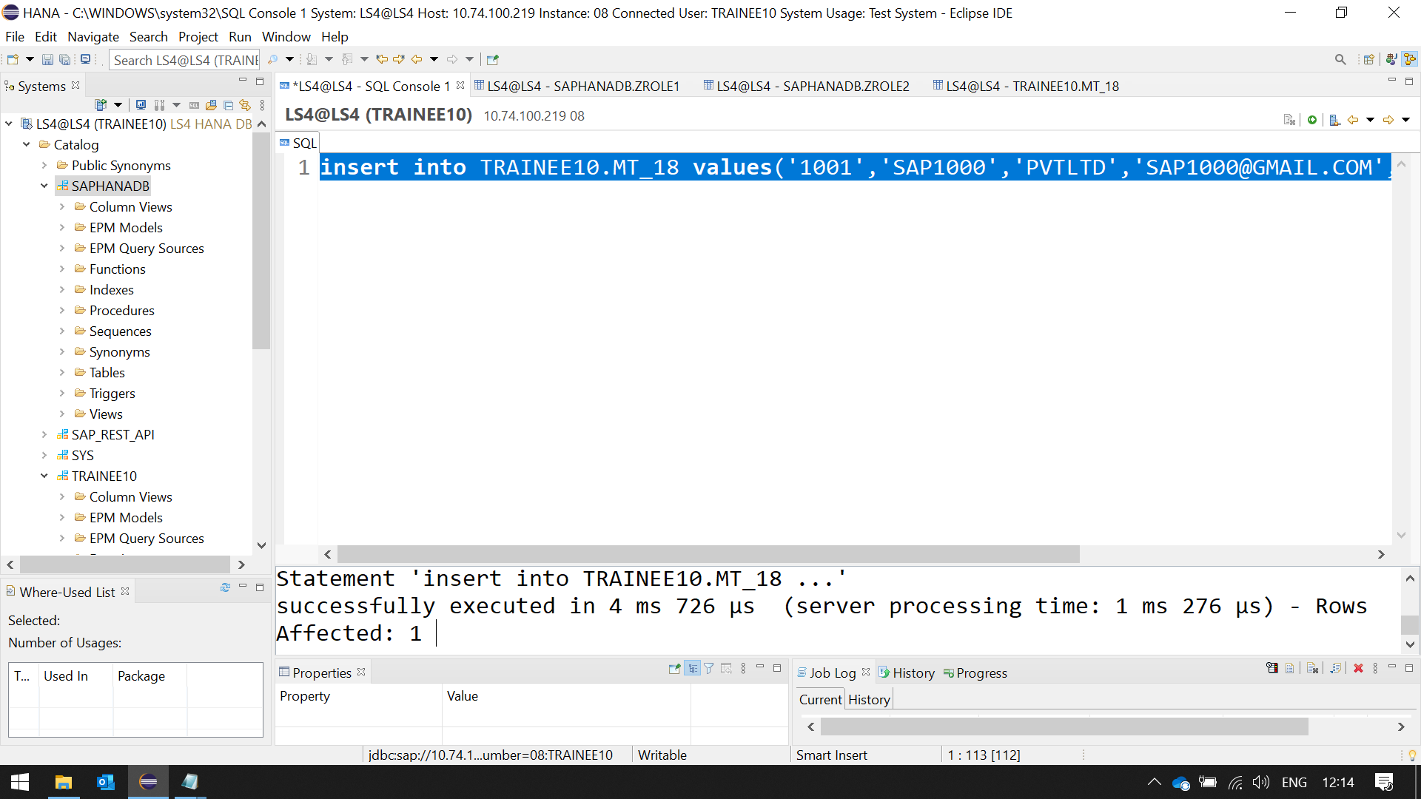

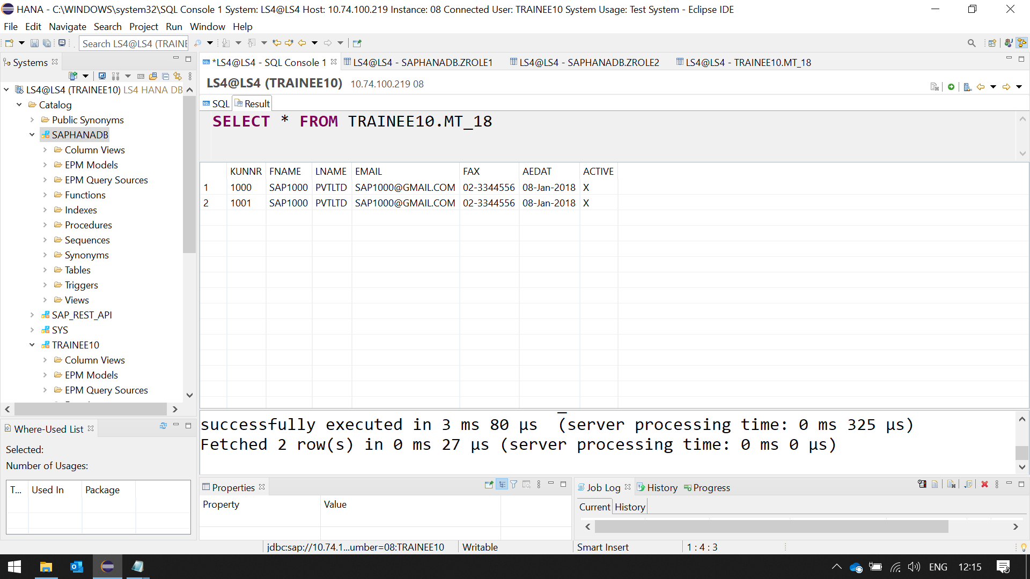

**select**

KUNNR,

**ucase**(FNAME) **as** fnamec,

**concat**(fname,LNAME) **as** fullname,

EMAIL,

FAX,

AEDAT,

ACTIVE

**from** "TRAINEE10"."MT_18"

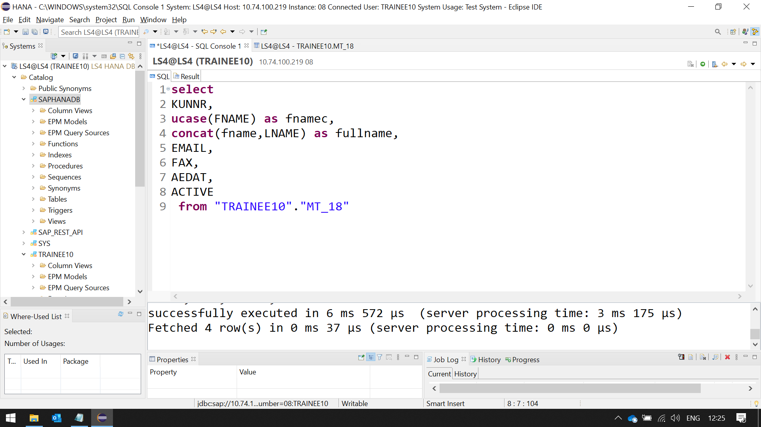

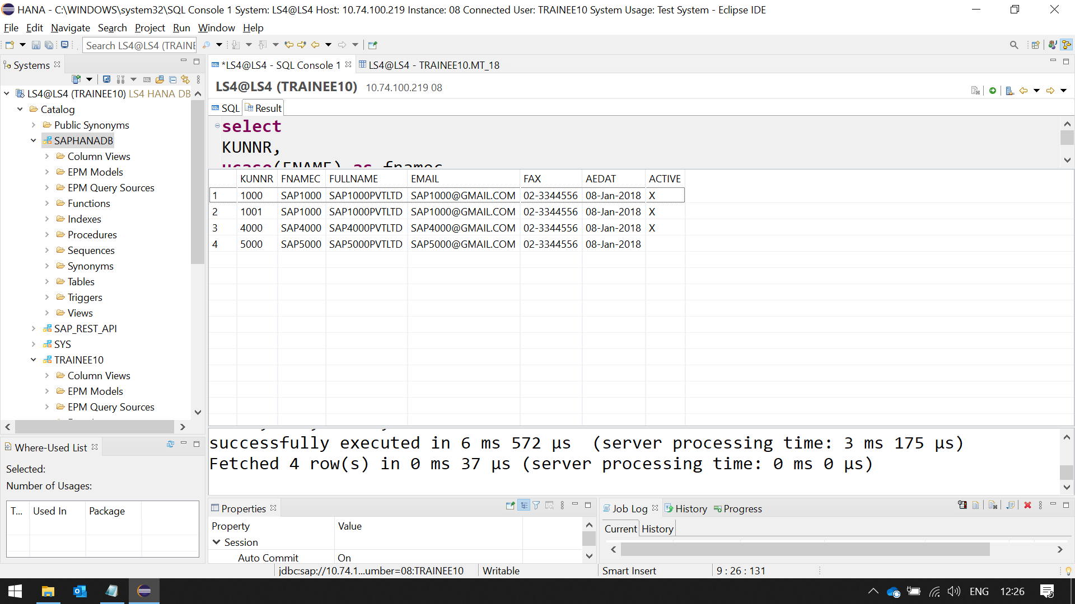

**select**

KUNNR,

**ucase**(FNAME) **as** fnamec,

**concat**(fname,LNAME) **as** fullname,

EMAIL,

FAX,

AEDAT,

**case** ACTIVE

**when** 'X' **then** 'success'

**when** '' **then** 'failure'

**else** 'Invalid'

**end** activealias

**from** "TRAINEE10"."MT_18" 